**Authors: Marcus Noble1, Anders Markvardsen1, Lottie Greenwood1, Martyn Giggs2, Nicholas Draper2, Tom Griffin3, Mathieu Doucet4 and Shelly Ren4**

**Affiliations:** 1) ISIS-STFC, 2) Tessella Ltd & ISIS-STFC, 3) SCD-STFC, 4) SNS-ORNL

**Preferred type of communication:** Oral

**Topics:** “Neutron Instrumentation, Optics, Sample Environment, Detectors and Software”

**Title (plain text only):** Automated data reduction at ISIS

**Title (formatted text):** Automated data reduction at ISIS

Introduction of the Mantid[1,2] data reduction framework at ISIS has simplified the data reduction for several experiments to the extent that the user interaction can be repetitive and could be automated. Automating the data reduction for these experiments frees up time for instrument scientists and users of neutron facilities to focus on making the best use of their allocated beam time and extracting value earlier with data analysis. We have introduced an automated data reduction system requiring minimal human intervention, which can support varied data reduction workflows, however simple or complex.

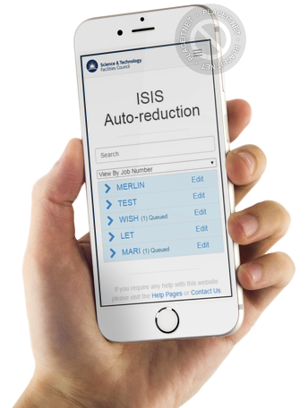This approach was pioneered by the SNS [3] and, as part of the Mantid collaboration, a similar system was deployed in March this year at ISIS and is being rolled across the instrument suite.

The system kicks off data reduction jobs as soon as runs are completed on an instrument. Job management is performed using message queues and a central message broker. The data reduction jobs are pre-defined but user editable python scripts with access to many software libraries, including Mantid. A mobile friendly web interface, which can be accessed anywhere, enables access to monitor job progress viewing reduction results. The interface allows data reduction to be rerun with different parameters, parameters to be set for future runs as well as monitoring the progress of your jobs.

This new system will be demonstrated using ISIS data and using Mantid data reduction, and giving overview of its benefits, but also an insight into how the system works under the bonnet.

**References**

[1] [www.mantidproject.org](http://www.mantidproject.org)

[2] O. Arnold, et al., Mantid—Data analysis and visualization package for neutron scattering and μSR experiments, Nuclear Instruments and Methods in Physics Research Section A, Volume 764, 11 November 2014, Pages 156-166

3